POLICIES AND PROCEDURES

FIN.SOP.X.014B
Non PO based invoice processing
GSC / Accounts Payable
FNM Standard Operating Procedure

DISCLAIMER

Standard Operating Procedures (SOPs) provide a step-by-step guide for staff directly involved in the processing of administrative actions to support and facilitate the implementation of WHO policies and procedures. The SOPs are for guidance only; they are neither authoritative nor binding. The SOPs reflect the policies and procedures of WHO at the time of writing; however, policies and procedures change from time-to-time. In the case of a conflict between the SOPs and the WHO eManual provisions, the WHO eManual provisions take precedence.

DOCUMENT SPECIFICATIONS

Version Version | Date of revision | Author (s) / Dept / Unit | Reviewer | Approver | Indicate which section changed compared to previous version
0.1 | Mar 2012 | R. Duraiswami/GFIAP &  B. Hauser (FNM/HQ) | A. Ritchie / GFI | N. Jeffreys / FNM
0.2 | 21-May-2012 | R. Duraiswami/GFI/AP | A. Ritchie / GFI | N. Jeffreys / FNM | Text, References modified
0.3 | 29-Dec-2017 | TJ. Lim/GFI/AP | R. Ephrem / GFI | CARDENAS, Francisco E.v., GSC  N. Jeffreys / FNM | Overall update to comply automated AP processes effective 12-Apr-2017.

INTRODUCTION

  - Overview/Description
This Standard Operating Procedure provides guidance on the processing of non-Purchase Order (PO) based invoices by the GSC Accounts Payable (AP) unit.

  - General Guidance / Business Rules
    - In general, the use of purchase orders (PO) in the procure to pay (P2P) process is very important, as it allows the organization to better control its supplier relations and financial commitments to 3rd parties; also planning and utilization of allocated resources to technical units.

    - However, in some cases the use of purchase orders may not be necessary from an internal controls point of view or inefficient from an administrative standpoint.

    - Non-PO based related invoices are generally relate to one of the below transactions :
    - Reimbursement of medical expenses related to entry, periodic or exit medical examinations (Form 737)
    - Reimbursement of security expenses
    - Credit memos, SSA payments, etc.
    - Recurring invoices such as indemnity payments
    - Payroll 3rd Party payments (Staff Association, MEC) – as a part of monthly payroll run
    - Shipment of private cars reimbursement (Form 480)
    - UNFCU third party payments (Payroll, suppliers and travel per diem related)

    - GSC AP does not process invoices for non PO based payments listed in paragraph 5 below. All such non PO based payment request should be submitted by requestors via iSupplier Portal.

    - Types of non PO based requests to be submitted via iSupplier portal;
      - Credit Card Invoice
      - Death Grant
      - Employee Relocation of cars/ Reimbursement against shipment of private cars
      - Hospitality (Event, seminars etc.)
      - Insurance claim xx % paid to employee
      - MORSS (Minimum Operating Residential Security Standards)
      - Medical Expenses to employees
      - Payroll Third Party payment/ Employee Contribution towards Saving plan (UNFCU)
      - Refund to Donor
      - Rental Advance
      - Replenishment to country office bank account (eImprest)
      - SSA (Special Service Agreement) Medical Claims
      - SSA Overtime claim
      - SSA salary
      - Salary advance
      - Salary Void
      - Supplier invoice without PO

Non PO based invoices and transactions to be processed by GSC AP
The iSupplier portal does not support the processing of the following type of non PO based transactions. These are processed by GSC AP.

- Credit Note:
      - Sent by supplier to reduce invoice amount, which relates to wrong amount or quantity.
      - Normal processing should apply the credit note to PO matched invoice, however, if PO status is ‘Finally Closed’, manual process of direct credit to PO PTAEO is required.
      - The accounting entries in GSM distribution level will be as follows:
Debit Payables Supplier Balance Control
Credit PTAEO (related to PO as per invoice)
      - When an invoice to be submitted through iSuppliers has a corresponding credit note, requestors need to follow the following steps:
    - Credit memo should be submitted first to GSC AP for processing by creating a ticket through MyService;
    - GSC AP shall process the Credit Note in GSM manually and informs the requestor;
    - Upon receipt of confirmation of Credit Note creation in GSM by GSC AP, the requestor shall submit supplier invoice with the full amount via ‘iSupplier’ Portal; The communication regarding the credit note may be attached in the ‘iSupplier’ non-PO based invoice submission;
    - Once the iSupplier invoice is approved, the system does the netting off automatically for payment

- Refund from Supplier
      - Refund from supplier is money returned due to duplicate or overpayment of an invoice. It is recorded as a credit memo in GSM AP Invoice Workbench;
      - credit memo is manually created in GSM to return the funds to the PTAEO initially charged, or
      - a refund from supplier can be offset against a balance due from other unpaid invoices of the same supplier.
- Prepayment
      - A Prepayment invoice is manually created to initiate an advance payment to a supplier. For example, to pay deposit for the purchasing of assets such as ambulance, books for library or to pay deposit for the booking of hotel. Later, the prepayment can be applied to one or more invoices received from the supplier to offset the amount paid to them.
      - This process covers the procedure to be followed if there is a requirement to make an advance payment to suppliers or service contractors, either in full or in part for goods or services supplied or rendered. (Refer to FIN.SOP.X.030 for the detailed process on prepayments)

Reference Material

    - WHO eManual

    - X.2.1 Commitments and encumbrances
http://emanual.who.int/p10/s02/Pages/X21CommitmentsandEncumbrances.aspxxxx

    - iSupplier Userguide
https://workspace.who.int/sites/GSMT/Documents/AutomatedInvoiceProcessing_userguide_EN.pdf

    - Related SOPs
- FIN.SOP.X.014A PO based invoice processing
- FIN.SOP.X.014C Manual invoice processing-VAT
- FIN.SOP.XVI.001 Direct Financial Cooperation Processing

    - Related Forms
- Form 480

- PROCESS FLOW

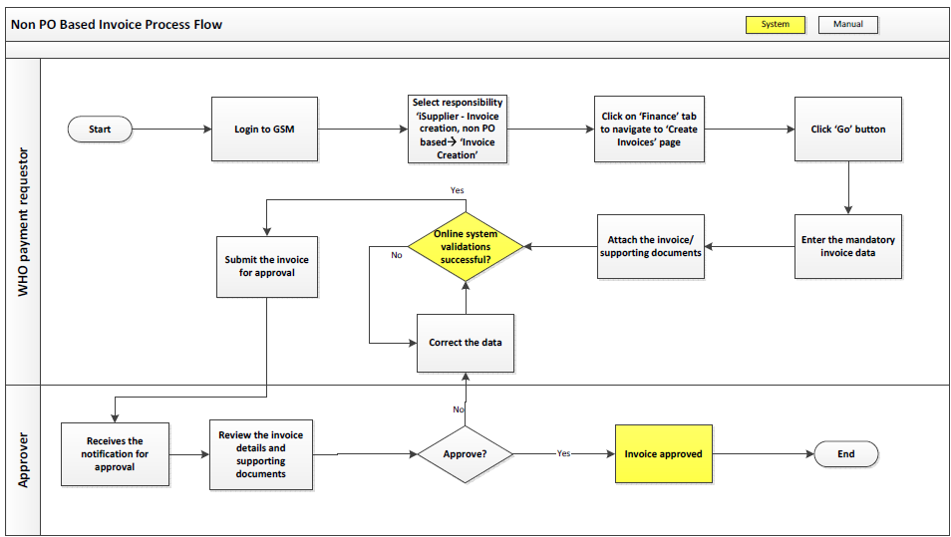
- PROCESS STEPS
A) Non-PO based invoice
Step | Control  Point | Type | Process | Role/Responsibility
1 |  | iSupplier | Non PO based request submission via iSupplier Portal.  For medical reimbursement: complete and attach form 737.  For shipment of private cars reimbursement: complete and attach form 480 | Requestor
2 |  | iSupplier | - Enter PTAEO and all mandatory fields.Supplier name  - Remit To  - Remit To Bank Account  - Invoice Sub-Type  - Invoice Number  - Invoice Date  - Currency  - Invoice Amount  - Invoice Description (optional)  - Manage Attachment  - PTAEO | Requestor
3 |  | iSupplier | Submit invoice.  For medical reimbursement: in addition to above mentioned items also attach email message/letter advising staff to undergo medical examination | Requestor
4 | C | iSupplier | Verify completeness and correctness of submitted documents and forms before providing approval. | Approver
5 |  | GSM | Invoice Validation on approved non PO based invoice (scheduled) | System - GSM
5.1 |  |  | If invoice status shows “Needs revalidation”, follow steps 5.2 – 5.4  GSM will perform the following validation checks:  - PTAEO funds check | Invoice Processor
5.2 |  |  | Click on “Holds”, then enter hold name and GSC hold reason. Notify requestor on hold reason.  Common hold reason;  - Voided payments (e.g invalid bank account number, beneficiary bank account closed, invalid sort code/swift code/ABA code/IBAN and etc)  - Insufficient funds of PTAEO | Invoice Processor
5.3 |  |  | Technical Unit to resolve reason for hold and provide update to Invoice Processor | Requestor
5.4 |  |  | Once technical unit has resolved issue and provided update, amend information in the system and proceed with invoice revalidation | Invoice Processor
6 |  | GSM | Invoice Payment | CPP team

B) Refund from supplier

Step | Control  Point | Type | Process | Role/Responsibility
1 |  | Online  ServiceNow | Creates self-service incident ticket for Invoice Processing group via ServiceNow and attach supporting documents. | Requestor
2 |  | Online  ServiceNow | Log on to ServiceNow using your login ID.  Retrieve incident tickets and assign tickets to own queue. | Invoice Processor
2.1 |  |  | Click on AP Invoice Processor responsibility. Next click on Invoice Entry → Invoices. | Invoice Processor
2.2 |  |  | Under field type select “Credit Memo”. Then enter supplier number, invoice date,invoice currency, amount, document category, incident ticket number. Invoice number is entered according to the details of PO or original invoice paid. | Invoice Processor
2.3 |  |  | Enter pay group as ’TEMPORARY’ | Invoice Processor
2.4 |  |  | In description field enter your initial, description and paygroup required. | Invoice Processor
2.5 |  |  | Click on distribution, then enter PTAEO/GL account. | Invoice Processor
2.6 |  |  | Click on “Close” button | Invoice Processor
2.7 |  |  | Upload refund documents in GSM Enterprise Content Management system (ECM). | Invoice Processor
3 |  | GSM | Invoice Validation | System / IP
3.1 |  |  | Click on “Actions” → tick “Validate” → click “OK” | Invoice Processor
3.2 | C |  | Tick Validate, then OK | System
3.3
4 | C |  | Invoice Approval | Invoice Supervisor
5 |  | Online | Reassign incident ticket to CPP team | Invoice Processor
6 |  | GSM | Refund Entry | CPP team

- KEY RISKS & COMPENSATING CONTROLS

Risks | Compensating Controls | Process Step
4.1 Internal Risk
In accurate manual invoice creation by non-PO / GRN match (invalid supporting documents) | The iSupplier approver does a check before approving the transaction in GSM. | 5A – Step 4
Duplicate payment | Standardized invoice naming convention | 5A – Step 2
Unauthorized manual invoice creation;  Unauthorized application or release of Manual hold on an invoice;  Unauthorized cancellation or modification to invoice details; | List of staff having access to invoice processor, invoice approver and iSupplier - Invoice Creation responsibility are circulated by GSD and reviewed by business owners. Also, new request for access to the above responsibilities are granted by GSD only after the approval by process owners (approval matrix available). Also, the details of invoice created by and last updated by user details are captured in GSM. | System control
4.2 External Risk
Duplicate payment request sent by  Requestor | iSupplier approvers need to check and verify before approving the payment request. Also there is a inbuilt system validation to check duplicate invoices for the same supplier | 5A – Step 4

